**Neural Hack + Business Cipher (Team 06)**

**Introduction:**

The basic usage of this website is to detect whether a person is suffering from diabetes or not by getting a few medical parameters of the person from the user. It uses a trained ML model to predict an 86% accurate result. Detailed description of the User Interface of the site is discussed below.

**Navigation Bar:**

It contains links to different pages such as **Home** which is the page viewed by the user currently, **Login/Register** which allows the user to login to their account or create new account in our site, **One Time User** which allows the user to enjoy the basic feature of our website without any registration and **AIML Geek** which redirects the user to a GitHub repository containing our ML algorithms for references (if interested).

Navbar-Image



**Home Page:**

In the home page you will be able to find a detailed description of our product, its advantages and its features and a detailed description about ML training along with flow chart (if interested). Along with that details of our team members can be viewed. Finally, you can find the contact us section to directly contact us for any queries and FAQ’s section and our office location and contact.

Home Page-Image

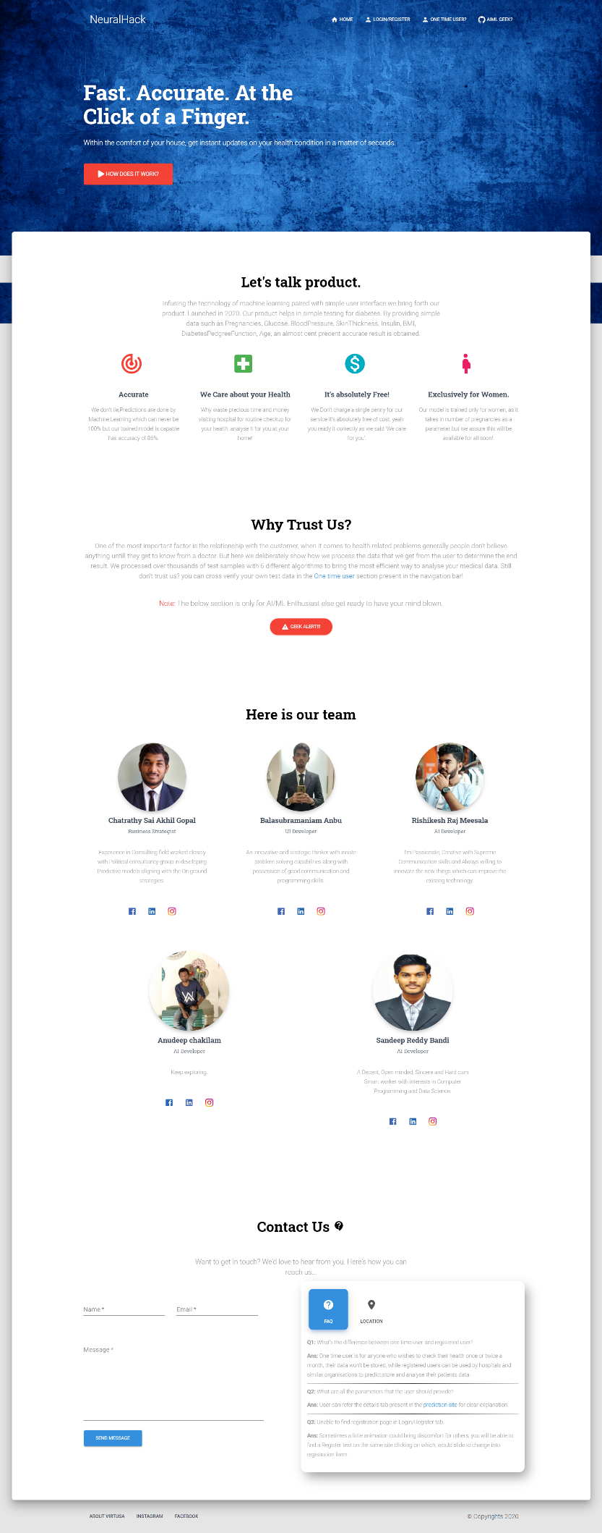

**One Time User:**

This is an important page where you can directly access the primary feature provided by our site, that is you can directly enter the required medical data of the patient to find the possibility of diabetes for them, the notes tab present in the left side contains important note and below that you will be able to find a details tab which displays a detailed description about the parameters that you must provide in-order to predict the outcome.

**Note:** Important things to be noted about One-time user is that the data entered by the user won’t be stored in the database for future references. This section will be useful for normal people who checks their health once or twice a month, so creating a separate login for them will be unnecessary.

One Time User Page-Image

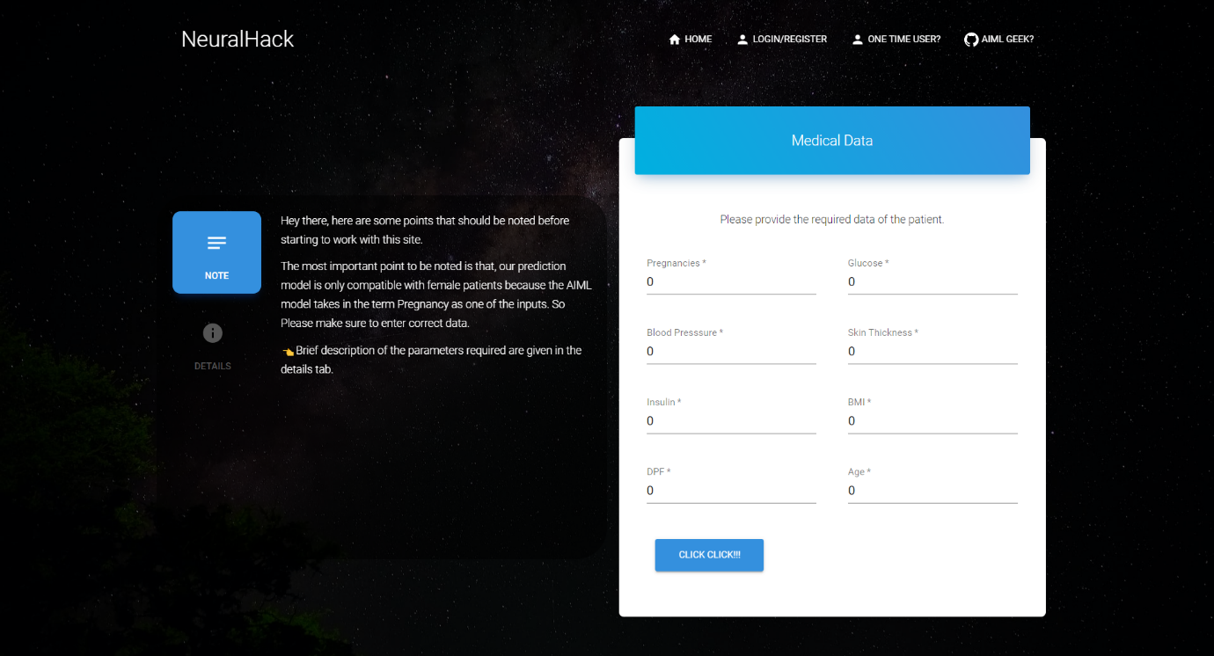

**AIML Geek?**

Clicking on this session will redirect you to our GitHub repo where we have displayed and explained in detail about our trained ML model so that interested people may pay a visit to it.

**Login/Register:**

This section is exclusively for all the organizations such as hospitals who wish to use our service in a daily basis. In order to have this access a representative from the organization has to create an account in our site by providing the required details after that they will be redirected to the login page where they can login to view the features provided to them. Once successfully logged in, they will be able to see a customized Navigation Bar containing their name along with a **Dashboard** and a dropdown box name **Others** containing **Predict** and **Profile** links.

Login Page-Image

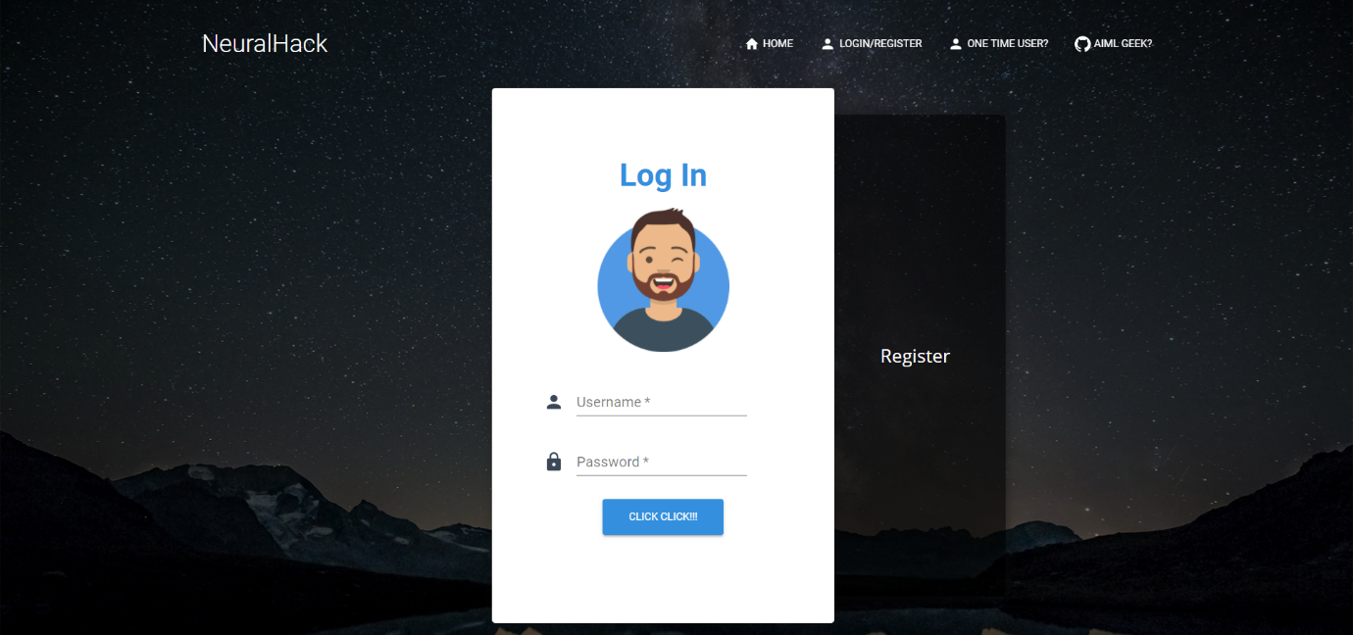

Register Page-Image

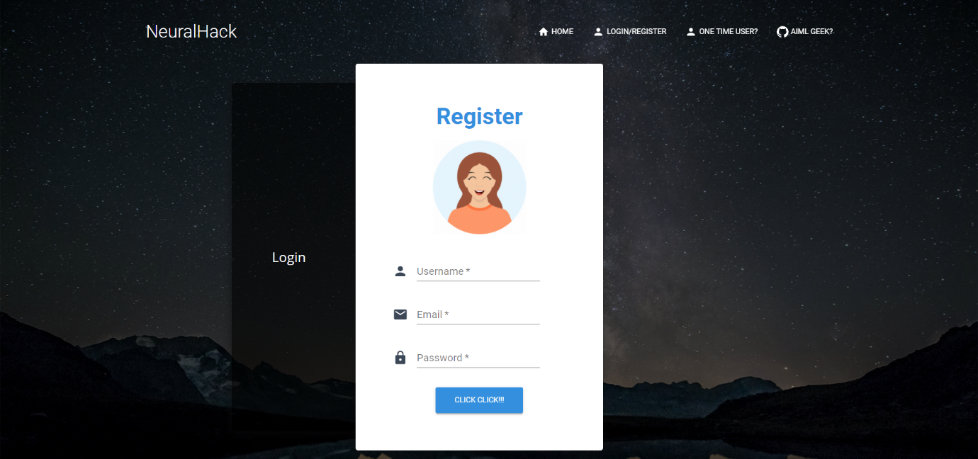

**Predict:**

Once login is successful the user will land on the **Predict** page that contains similar layout as the **One Time User** page but with 2 additional inputs (Patient name and Id) to uniquely identify the patient. After filling in the parameters when the user clicks the “Click Click” button the probability will be displayed near the button itself also the details will be saved in the database for future usage. It should be noted that the probability of having diabetes is only displayed and after analyzing we have found the threshold value as 70% and above this may vary person to person so the probability is displayed for convenience.

Predict Page-Image

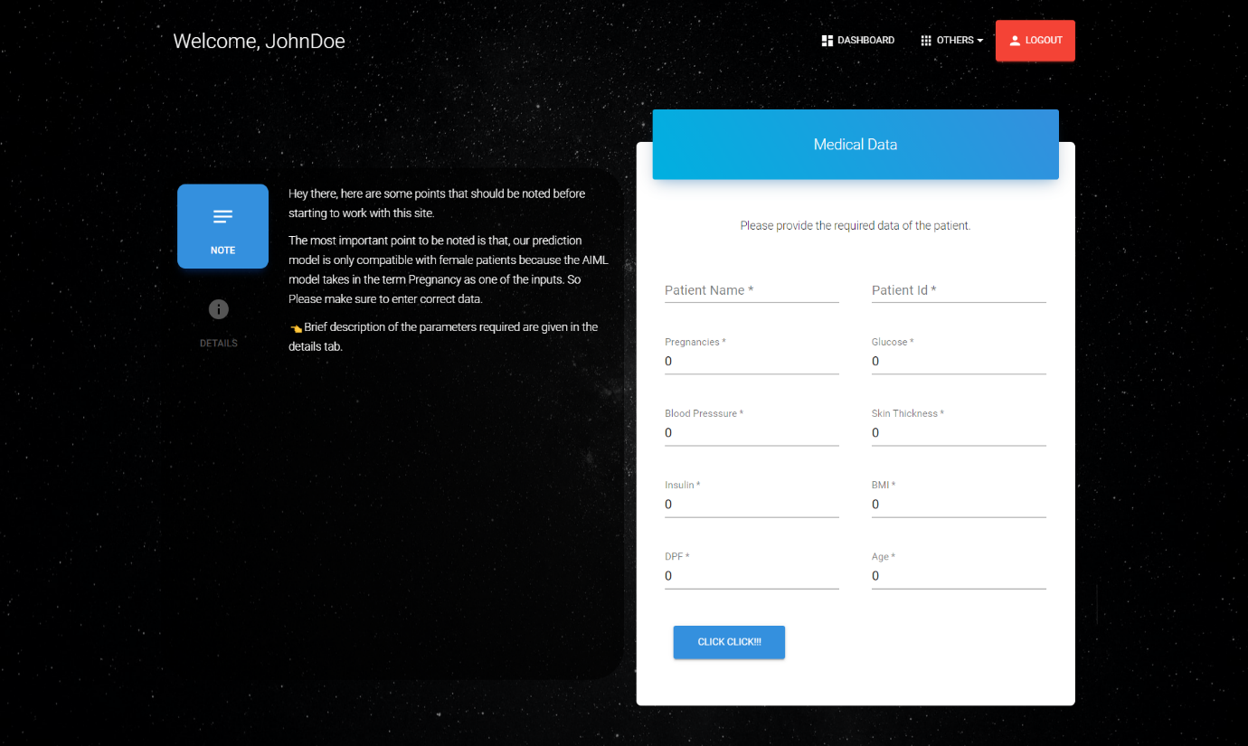

**Profile:**

In this page the representative is allowed to update the general details about themselves and their company in order to keep track of the users by the admin. Once the user clicks the Update Profile button after filling in all the required content, the details will be uploaded to the backend and also the page reloads to display their data in the form of User Profile card to the right side of the form. This may be used in the future for linking two or more organizations together.

Profile Page-Image

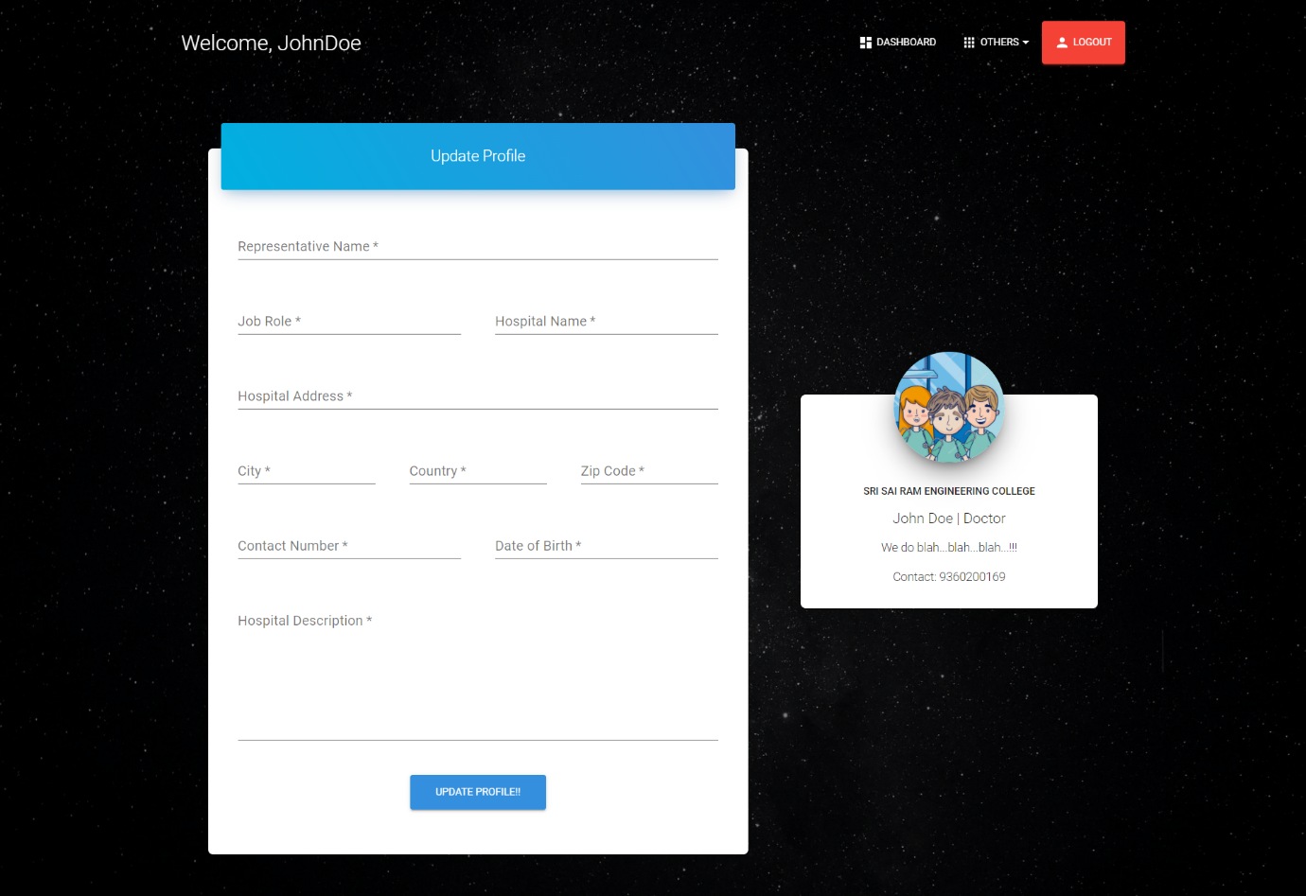

**Dashboard:**

It contains additional features for the logged in users such as total number of patients analyzed so far, total number of positive cases predicted and total number of negative cases predicted, scrolling down the user will find a Line graph having last 7 days in the X axis and the number of patients in the Y axis, the Line graph itself contains 3 different graph analysis. Starting with the Red line it indicated the total number of patients predicted positive for diabetes on a particular day then the Green line it indicated the total number of patients tested negative for diabetes on that day and finally the Blue line indicating total number of patients analyzed on that particular day.

Next to that user will be able to find a Pie Chart depicting the Positive vs Negative prediction ratio so far. Scrolling down there will be a table containing the patients data analyzed so far by the user. User can filter the table name or id wise using the search option present in the top right corner of the table also they can download the table in .csv or pdf format using the export option present next to it for their organizations reference.

Dashboard Page-Image

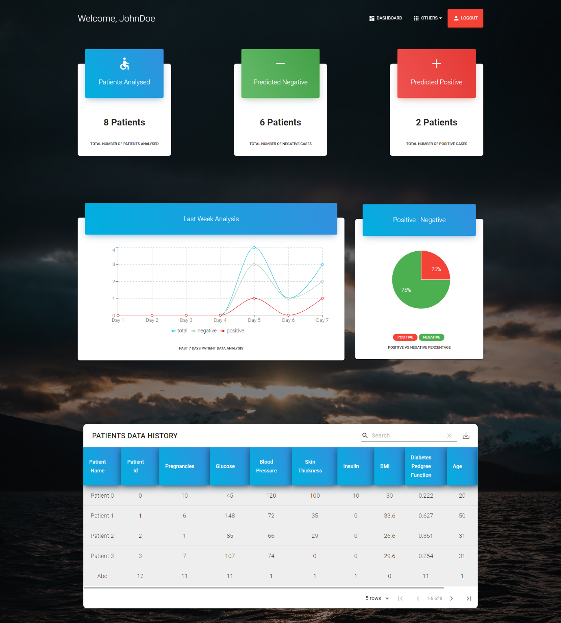

**Logout:**

At the end of the Navigation bar a logout button is present clicking on which will log out the user and they won’t be able to access back the page by clicking back button, only possible way is to login in again. Once logged out the user will be redirected to the home page.

**General Flow:**

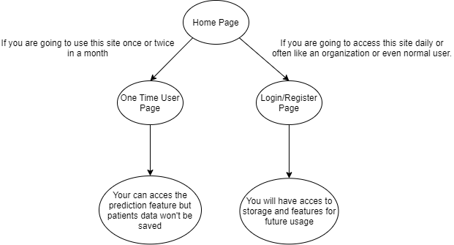

**To host both Backend and Frontend in localhost follow the procedure:**

**Frontend:**

-->Visit <https://nodejs.org/en/download/> and download the node installer for your machine and install npm using the pop-up wizard.

--> Now clone the frontend code from “” and move to react-app folder by typing “cd app-name” and type in “npm install” in your command terminal to install the dependencies.

--> Now type “npm start” in the command terminal to start the react-app.

--> Now this will open a site running at “localhost:3000” in your machine and displays the frontend of the site.

**Backend:**

-->Make sure python is installed in your machine and open another console terminal and type in “python -m pip install Django” to install Django in your machine.

-->Now clone the backend code from “” and move inside the project folder and in your console terminal type in “pip install requirements.txt” to install the requirements.

-->Now in your console terminal type in “python manage.py runserver” to run the backend server in your local machine, you can find the backend API and admin login at “localhost:8000”.

--> You can create a superuser to access the admin site by “python manage.py createsuperuser” and type in the username email password fields while prompted.

--> This will complete the installation of both frontend and backend in your local machine.